Date: 11/07/25
Roll No. and Name: 24BCE174 and Khush Pithva
Course Code and Name: 2CS502CC25 and Object Oriented Programming
Practical No: 1A
Aim: How to install the configuration of C++ in Visual Studio Code
Methodology followed:
1. Install VS Code from code.visualstudio.com
2. Install MinGW-w64 Compiler
• Download from mingw-w64.org
• Add bin path to Environment Variables → Path
3. Install C/C++ Extension in VS Code
4. Write .cpp File and Run via:
[ g++ file.cpp -o file
./file ]
Practical No: 1(b)
Aim: Create a program that prints 'Hello, C++ World' using cout and includes basic headers.
Methodology followed:
#include<bits/stdc++.h>
using namespace std;
int main()
{
cout<<"Hello world!"<<endl;
return 0;
}
Output:

Practical No: 1(c)
Aim: Develop a program that reads two integers from the user and displays their sum.
Methodology followed:
#include<bits/stdc++.h>
using namespace std;
int main()
{
int a,b;
cout<<"Enter a and b :";
cin>>a>>b;
cout<<"Sum : ";
cout<<a+b<<endl;
return 0;
}

Output:

Practical No: 1(d)
Aim: Create a program to swap two variables using a third variable and display results before and after swapping.
Methodology followed:

#include<bits/stdc++.h>
using namespace std;
int main()
{
int x,y;
cout<<"Enter X and Y :";
cin>>x>>y;
int temp=x;
x=y;
y=temp;
cout<<"After swap X : "<<x<< " Y : "<<y<<endl;
return 0;
}
Output:

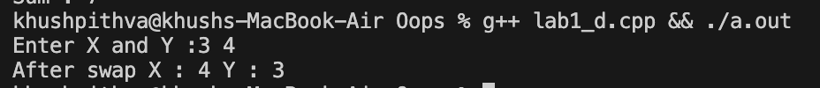

Practical No: 1(e)
Aim: Write a program that calculates and displays the average of three numbers entered by the user.
Methodology followed:
#include<bits/stdc++.h>
using namespace std;
int main()
{
int a,b,c;
cout<<"Enter a , b and c :";
cin>>a>>b>>c;
cout<<"Averag : ";
cout<<(a+b+c)/3;
return 0;
}

Output:
Conclusion:
We configured the C++ development environment in Visual Studio Code and explored fundamental programming concepts. Through writing basic programs, we practiced using cout, cin, arithmetic operations, variable swapping, and average calculations, establishing a solid foundation in C++.

